|  |  |
| --- | --- |
|  | Malawi Government |

**NKHOTAKOTA DISTRICT AGRICULTURE OFFICE**

**BACKSTOP AND FACILITATE ESTABLISHMENT OF INTEGRATED HOMESTEAD FARMING (IHF) 2.1.5.4**

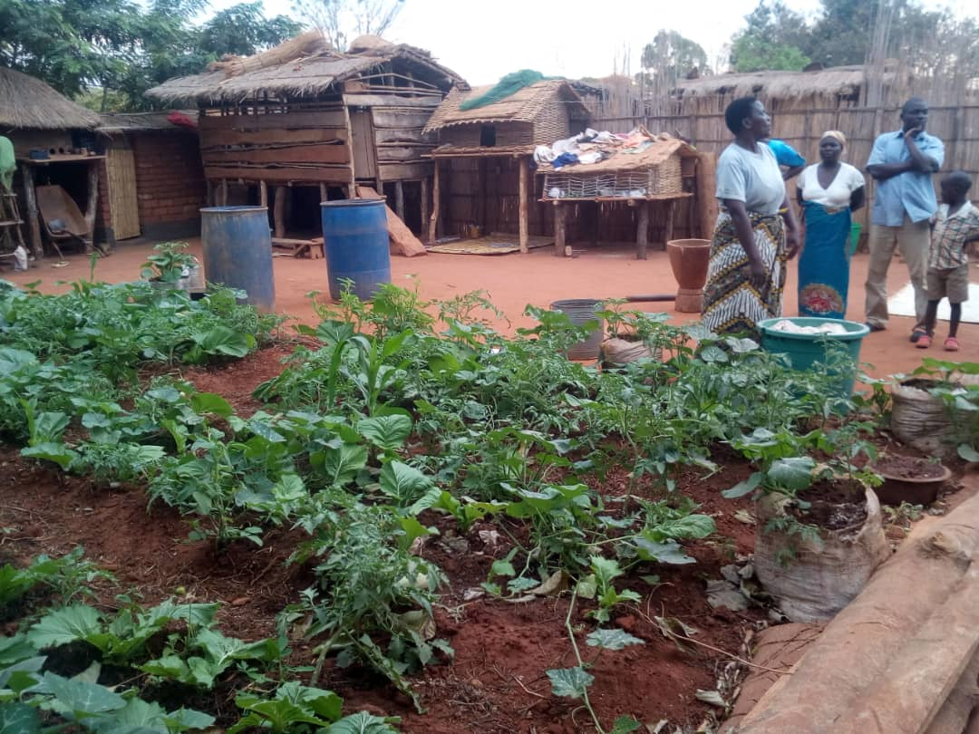

***One of the household practicing integrated homestead farming in Zidyana EPA***

**28rd August, 2018**

**Introduction**

Integrated Homestead Farming (IHF) is the growing of diversified crops and rearing of small stock or aquaculture around the home for improving food security and nutrition. IHF provides simple food-based approaches to resolving nutrient deficiencies through successful establishment and management of integrated farming at household, institutional and community settings. Nkhotakota district agriculture office is one of the intuitions which are promoting IHF in across the district of Nkhotakota. For proper implementation of IHF there is need to technically backstop the implementation of the interventions by Subject matter specialists as front line staff establish IHF.

The department of extension in liaison with other technical department organize an activity to establish IHF among selected households in the district. The resources for the activity were drawn from SAPP activity 2.1.5.4 in first quarter of 2018-2019 financial year. A total of 1114 households had been practicing IHF using different interventions.

**Objective**

* It increases production of nutrient rich plant and animal foods.
* It promotes sustainable utilization of resources at household level.
* Promote good agricultural production practices

**Outcome**

* Increased number of household which are food and nutritional self sufficiency

**Procedure**

The targeted households which are in model villages were oriented on the concept of IHF. In the previous quarters some of these households were given start up input like indigenous vegetable seeds and small stock like chickens meant for pass on. They oriented on good agriculture practices (GAP) on both corps and livestock which they adopted.

**Observation and recommendations**

In most household good agricultural practices were followed while in some households they were not fully adopted. Those who were following GAP they were encouraged to continue doing so. For those who were not following GAP demonstrations were mounted for them to appreciate so that they can practice in their respective households. The demonstrations included demonstrations on backyard gardening in terms of bed making and even planting in sacks; standard housing for chickens and goats**.**

The interventions being implemented in the households included, fruit production, small stock production and backyard gardening. These households were also encouraged to be participating in cooking demonstrations so that they can make effective use of their produce.

**Way forward**

* For those households which received fruit trees seedlings they were advised to keep on watering the seeding and protect them from damage by different livestock species
* Routine vaccination of chickens against Newcastle.